本地部署Gemma-4-26B-it大语言模型

生产环境中部署vLLM，请靠下图：
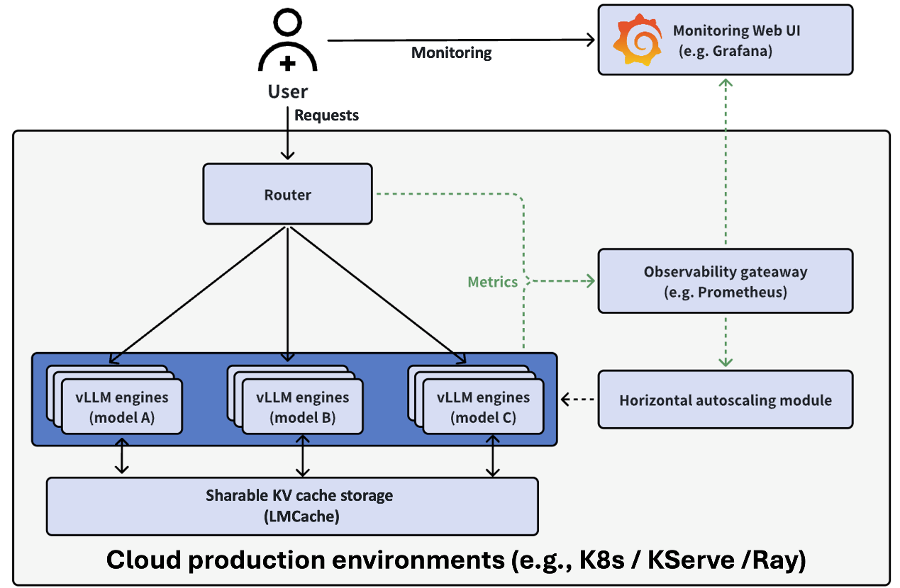
此图取自https://github.com/vllm-project/production-stack。

一、准备环境
Ubuntu 22.04 + INVIDIA RTX 4090d 24GB + docker + Open WebUI + vLLM + gemma-4-26B-A4B-it-AWQ-4bit

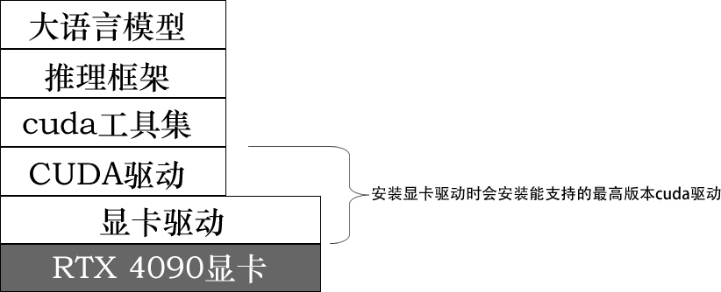

1. 安装INVIDIA RTX 4090d 24GB显卡的最新驱动：
root@fujunservers:~# apt purge nvidia\* -y
root@fujunservers:~# apt install pkg-config libglvnd-dev -y
root@fujunservers:~# shutdown -r now
root@fujunservers:~# wget https://us.download.nvidia.cn/XFree86/Linux-x86_64/595.58.03/NVIDIA-Linux-x86_64-595.58.03.run
root@fujunservers:~# chmod +x NVIDIA-Linux-x86_64-595.58.03.run
root@fujunservers:~# ./NVIDIA-Linux-x86_64-595.58.03.run
……后面的选择都是默认即可
root@fujunservers:~# shutdown -r now
root@fujunservers:~# nvidia-smi
Sun Apr 19 11:18:51 2026
+-----------------------------------------------------------------------------------------+
| NVIDIA-SMI 595.58.03 Driver Version: 595.58.03 CUDA Version: 13.2 |
+-----------------------------------------+------------------------+----------------------+
| GPU Name Persistence-M | Bus-Id Disp.A | Volatile Uncorr. ECC |
| Fan Temp Perf Pwr:Usage/Cap | Memory-Usage | GPU-Util Compute M. |
| | | MIG M. |
|=========================================+========================+======================|
| 0 NVIDIA GeForce RTX 4090 D Off | 00000000:AF:00.0 Off | Off |
| 31% 27C P8 5W / 425W | 15MiB / 24564MiB | 0% Default |
| | | N/A |
+-----------------------------------------+------------------------+----------------------+

+-----------------------------------------------------------------------------------------+
| Processes: |
| GPU GI CI PID Type Process name GPU Memory |
| ID ID Usage |
|=========================================================================================|
| 0 N/A N/A 2184 G /usr/lib/xorg/Xorg 4MiB |
+-----------------------------------------------------------------------------------------+
发现：显卡为NVIDIA GeForce RTX 4090 D（即4090的阉割版），显存24GB，显卡驱动版本为595.58.03，随显卡驱动一起安装的CUDA驱动的版本为13.2。下面安装cuda-toolkit（工具集）的版本不能朝超过13.2。

2. 安装CUDA工具集（版本13.0）:
root@fujunservers:~# wget https://developer.download.nvidia.com/compute/cuda/repos/ubuntu2204/x86_64/cuda-ubuntu2204.pin
root@fujunservers:~# mv cuda-ubuntu2204.pin /etc/apt/preferences.d/cuda-repository-pin-600
root@fujunservers:~# wget https://developer.download.nvidia.com/compute/cuda/13.0.0/local_installers/cuda-repo-ubuntu2204-13-0-local_13.0.0-580.65.06-1_amd64.deb
root@fujunservers:~# dpkg -i cuda-repo-ubuntu2204-13-0-local_13.0.0-580.65.06-1_amd64.deb
root@fujunservers:~# cp /var/cuda-repo-ubuntu2204-13-0-local/cuda-*-keyring.gpg /usr/share/keyrings/

root@fujunservers:~# apt update
root@fujunservers:~# apt install -y cuda-toolkit-13-0

llm@fujunservers:~$ vim ~/.bashrc
……
export PATH=/usr/local/cuda-13.0/bin${PATH:+:${PATH}}
export LD_LIBRARY_PATH=/usr/local/cuda-13.0/lib64${LD_LIBRARY_PATH:+:${LD_LIBRARY_PATH}}
export CUDA_HOME=/usr/local/cuda-13.0

llm@fujunservers:~$ . ~/.bashrc
nvcc -V
nvcc: NVIDIA (R) Cuda compiler driver
Copyright (c) 2005-2025 NVIDIA Corporation
Built on Wed_Jul_16_07:30:01_PM_PDT_2025
Cuda compilation tools, release 13.0, V13.0.48
Build cuda_13.0.r13.0/compiler.36260728_0

可参考https://developer.nvidia.com/cuda-13-0-0-download-archive?target_os=Linux&target_arch=x86_64&Distribution=Ubuntu&target_version=22.04&target_type=deb_local

3. 安装docker等：
# nvidia-container-toolkit的安装源：
root@fujunservers:~# wget https://nvidia.github.io/libnvidia-container/gpgkey
root@fujunservers:~# cat gpgkey | gpg --dearmor -o /usr/share/keyrings/nvidia-container-toolkit-keyring.gpg
root@fujunservers:~# curl -s -L https://mirrors.ustc.edu.cn/libnvidia-container/stable/deb/nvidia-container-toolkit.list | \
sed 's#deb https://nvidia.github.io#deb [signed-by=/usr/share/keyrings/nvidia-container-toolkit-keyring.gpg] https://mirrors.ustc.edu.cn#g' | tee /etc/apt/sources.list.d/nvidia-container-toolkit.list

root@fujunservers:~# apt update
root@fujunservers:~# apt install docker.io nvidia-container-toolkit docker-compose-v2 -y
配置本地镜像库：
root@fujunservers:~# vim /etc/docker/daemon.json
{
"registry-mirrors": [
"https://docker.1panel.live",
"https://docker.1ms.run",
"https://dytt.online",
"https://docker-0.unsee.tech",
"https://lispy.org",
"https://docker.xiaogenban1993.com",
"https://666860.xyz",
"https://hub.rat.dev",
"https://docker.m.daocloud.io",
"https://demo.52013120.xyz",
"https://proxy.vvvv.ee",
"https://registry.cyou",
"https://mirror.ccs.tencentyun.com",
"https://no3hfwj9.mirror.aliyuncs.com"
]
}
添加INVIDIA运行时（会修改/etc/docker/daemon.json文件）：
root@fujunservers:~# nvidia-ctk runtime configure --runtime=docker
root@fujunservers:~# more /etc/docker/daemon.json
{
"registry-mirrors": [
"https://docker.1panel.live",
"https://docker.1ms.run",
"https://dytt.online",
"https://docker-0.unsee.tech",
"https://lispy.org",
"https://docker.xiaogenban1993.com",
"https://666860.xyz",
"https://hub.rat.dev",
"https://docker.m.daocloud.io",
"https://demo.52013120.xyz",
"https://proxy.vvvv.ee",
"https://registry.cyou",
"https://mirror.ccs.tencentyun.com",
"https://no3hfwj9.mirror.aliyuncs.com"
],

"runtimes": {
"nvidia": {
"args": [],
"path": "nvidia-container-runtime"
}
}
}

root@fujunservers:~# systemctl restart docker

4. 测试能否在gpu中运行：
llm@fujunservers:~$ sudo docker pull swr.cn-north-4.myhuaweicloud.com/ddn-k8s/docker.io/nvidia/cuda:12.2.0-base-ubuntu22.04
docker image tag swr.cn-north-4.myhuaweicloud.com/ddn-k8s/docker.io/nvidia/cuda:12.2.0-base-ubuntu22.04 nvidia/cuda:12.0-base-ubuntu22.04

docker run --rm --runtime=nvidia --gpus all nvidia/cuda:12.0-base-ubuntu22.04 nvidia-smi
Sun Apr 19 07:21:53 2026
+-----------------------------------------------------------------------------------------+
| NVIDIA-SMI 595.58.03 Driver Version: 595.58.03 CUDA Version: 13.2 |
+-----------------------------------------+------------------------+----------------------+
| GPU Name Persistence-M | Bus-Id Disp.A | Volatile Uncorr. ECC |
| Fan Temp Perf Pwr:Usage/Cap | Memory-Usage | GPU-Util Compute M. |
| | | MIG M. |
|=========================================+========================+======================|
| 0 NVIDIA GeForce RTX 4090 D Off | 00000000:AF:00.0 Off | Off |
| 31% 28C P8 4W / 425W | 15MiB / 24564MiB | 0% Default |
| | | N/A |
+-----------------------------------------+------------------------+----------------------+

+-----------------------------------------------------------------------------------------+
| Processes: |
| GPU GI CI PID Type Process name GPU Memory |
| ID ID Usage |
|=========================================================================================|
| No running processes found |
+-----------------------------------------------------------------------------------------+
能看到rtx显卡信息表，说明一切正常。

二、部署模型
1. 准备目录：
llm@fujunservers:~$ mkdir -p ~/llm-stack/{models,pipelines_plugins,open_webui_data}
llm@fujunservers:~$ cd ~/llm-stack
2. 从莫塔社区（https://www.modelscope.cn/）下载cyankiwi/gemma-4-26B-A4B-it-AWQ-4bit （cyankiwi/gemma-4-31B-it-AWQ-4bit太大，已经测试过24GB显存不够）：
llm@fujunservers:~/llm-stack$ sudo pip install modelscope
python -c "from modelscope import snapshot_download; snapshot_download('cyankiwi/gemma-4-26B-A4B-it-AWQ-4bit', local_dir='./models/gemma-4-26B-A4B-it-AWQ-4bit')"
或者：
llm@fujunservers:~/llm-stack$ python -c "from modelscope import snapshot_download; snapshot_download('dealignai/Gemma-4-26B-A4B-JANG_4M-CRACK', local_dir='./models/Gemma-4-26B-A4B-JANG_4M-CRACK')"
或者从huggingface.co的国内镜像https://hf-mirror.com下载：
llm@fujunservers:~/llm-stack$ sudo apt update
llm@fujunservers:~/llm-stack$ sudo apt install git git-lfs aria2
llm@fujunservers:~/llm-stack$ git lfs install

llm@fujunservers:~/llm-stack$ pip install -U huggingface_hub hf_transfer
llm@fujunservers:~/llm-stack$ export HF_ENDPOINT=https://hf-mirror.com
llm@fujunservers:~/llm-stack$ huggingface-cli download --resume-download --local-dir-use-symlinks False \
cyankiwi/gemma-4-26B-A4B-it-AWQ-4bit --local-dir ./models

3. 编写容器组合文件docker-compose.yml：
llm@fujunservers:~/llm-stack$ vim docker-compose.yml
services:
# ── 1. vLLM 推理服务 (保持不变) ──────────────────────────────────
vllm:
image: vllm/vllm-openai:gemma4-cu130
runtime: nvidia
ipc: host
ports:
- "8000:8000"
volumes:
- ./models/gemma-4-26B-A4B-it-AWQ-4bit:/models
command: >
/models
--quantization compressed-tensors
--dtype float16
--max-model-len 32768
--gpu-memory-utilization 0.89
--served-model-name gemma-4-26B-A4B-it-AWQ-4bit
--trust-remote-code
--enable-auto-tool-choice
--tool-call-parser hermes
deploy:
resources:
reservations:
devices:
- driver: nvidia
count: all
capabilities: [gpu]
healthcheck:
test: ["CMD", "curl", "-f", "http://localhost:8000/health"]
interval: 30s
timeout: 10s
retries: 5
start_period: 120s
restart: unless-stopped
networks:
- llm-network

# ── 2. Pipelines 插件服务 (新增) ─────────────────────────────────
pipelines:
image: ghcr.io/open-webui/pipelines:main
container_name: pipelines
ports:
- "9099:9099"
volumes:
- ./pipelines_plugins:/app/pipelines
environment:
# 允许 Pipelines 访问宿主机网络，方便与 vLLM 容器通信
- PIPELINES_EXTRA_HOSTS=host.docker.internal:host-gateway
- PIPELINES_API_KEY=ILovePipelines
restart: unless-stopped
networks:
- llm-network
depends_on:
- vllm

# ── 3. Open WebUI (界面服务，已调整连接配置) ───────────────────────
open-webui:
image: ghcr.io/open-webui/open-webui:main
container_name: open-webui
ports:
- "3000:8080"
volumes:
- ./open_webui_data:/app/backend/data
environment:
# 让 WebUI 连接 vLLM 作为主要模型来源
- OPENAI_API_BASE_URL=http://vllm:8000/v1
- OPENAI_API_KEY=ILoveGemma4
# 让 WebUI 识别 Pipelines 提供的“插件模型”
# 注意：Pipelines 运行后，你会通过它获取新的模型能力
- ENABLE_PIPELINES=True
- PIPELINES_URL=http://pipelines:9099
- PIPELINES_API_KEY=ILovePipelines
- WEBUI_SECRET_KEY=ILoveOpenWebUI
- ENABLE_SIGNUP=true
# 配置Hugging Face国内镜像源，如果能访问https://huggingface.co就不要下面的环境变量：
- HF_ENDPOINT=https://hf-mirror.com
restart: unless-stopped
depends_on:
- vllm
- pipelines
networks:
- llm-network

# ── 容器网络与数据卷定义 ──────────────────────────────────────────
networks:
llm-network:
driver: bridge
检查docker-compose-llm.yaml的语法错误：
llm@fujunservers:~/llm-stack$ docker compose docker-compose.yml config -q
如果没有错误，就先下拉好容器镜像：
llm@fujunservers:~/llm-stack$ sudo docker compose pull
llm@fujunservers:~/llm-stack$ sudo docker images
IMAGE ID DISK USAGE CONTENT SIZE EXTRA
ghcr.io/open-webui/open-webui:main c2e4723fdbca 6.7GB 1.72GB U
ghcr.io/open-webui/pipelines:main b48e9bc338ce 4.81GB 1.28GB U
vllm/vllm-openai:gemma4-cu130 0d152595cd94 27.6GB 7.6GB U
vllm/vllm-openai:latest镜像很大，有9.61GB，可去https://hub.docker.com/r/vllm/vllm-openai/tags?name=gemma4查看其他镜像。
4. 正式启动
以后台模式启动两个容器（刚开始建议先启动一个vllm服务：sudo docker compose up -d vllm，看看有没有错）：
llm@fujunservers:~/llm-stack$ sudo docker compose up -d
以后如果只修改了其中一个服务，照样可以用上面的命令重建那个服务，而没有修改的服务不会重建。
实时查看启动日志（按 Ctrl+C 停止查看，容器继续运行）
llm@fujunservers:~/llm-stack$ docker compose logs -f

5. 查看显卡使用状态：
llm@fujunservers:~/llm-stack$ nvidia-smi
Sun Apr 19 19:20:13 2026
+-----------------------------------------------------------------------------------------+
| NVIDIA-SMI 595.58.03 Driver Version: 595.58.03 CUDA Version: 13.2 |
+-----------------------------------------+------------------------+----------------------+
| GPU Name Persistence-M | Bus-Id Disp.A | Volatile Uncorr. ECC |
| Fan Temp Perf Pwr:Usage/Cap | Memory-Usage | GPU-Util Compute M. |
| | | MIG M. |
|=========================================+========================+======================|
| 0 NVIDIA GeForce RTX 4090 D Off | 00000000:AF:00.0 Off | Off |
| 31% 36C P8 13W / 425W | 23573MiB / 24564MiB | 0% Default |
| | | N/A |
+-----------------------------------------+------------------------+----------------------+

+-----------------------------------------------------------------------------------------+
| Processes: |
| GPU GI CI PID Type Process name GPU Memory |
| ID ID Usage |
|=========================================================================================|
| 0 N/A N/A 2115 G /usr/lib/xorg/Xorg 4MiB |
| 0 N/A N/A 8415 C VLLM::EngineCore 23550MiB |
+-----------------------------------------------------------------------------------------+
显存基本上被用完，只剩下991MiB。在查看8000、3000和9099端口是否被监听：
llm@fujunservers:~/llm-stack$ ss -tnlp | grep -e 8000 -e Port -e 3000 -e 9099
State Recv-Q Send-Q Local Address:Port Peer Address:PortProcess
LISTEN 0 4096 0.0.0.0:9099 0.0.0.0:*
LISTEN 0 4096 0.0.0.0:3000 0.0.0.0:*
LISTEN 0 4096 0.0.0.0:8000 0.0.0.0:*
LISTEN 0 4096 [::]:9099 [::]:*
LISTEN 0 4096 [::]:3000 [::]:*
LISTEN 0 4096 [::]:8000 [::]:*
查看容器状态：
llm@fujunservers:~/llm-stack$ sudo docker compose ps
查看容器组合的日志：
docker compose logs
浏览http://<Open WebUI容器是宿主机ip>:3000，首次浏览会提示创建一个用户（第一次创建的用户就是管理员），以后再登陆就不能自行创建用户了，需要管理员协助新建用户（管理员登陆后的管理员面板上管理用户）。

关闭容器组合：
llm@fujunservers:~/llm-stack$ sudo docker compose stop
关闭并删除容器：
llm@fujunservers:~/llm-stack$ sudo docker compose down
查看容器组合的状态：
llm@fujunservers:~/llm-stack$ sudo docker compose ps [-a]

三、内网穿透
把局域网内的页面和大语言模型框架的api暴露到互联网上，以便从外面访问内网AI。
在云上主机（ip=88.160.60.46）上操作：
vim /etc/ssh/sshd_config
……
AllowTcpForwarding yes
GatewayPorts yes
……

systemctl restart ssh #或者systemctl restart sshd
在部署了Open WebUI的电脑上操作：
llm@fujunservers:~/llm-stack$ sudo apt install autossh -y
llm@fujunservers:~/llm-stack$ /usr/bin/autossh -M 0 -N -o "ProxyCommand=ssh win_user@10.3.230.36 -W %h:%p" -o "ServerAliveInterval=30" \
-R "80:localhost:3000" xxx@88.160.60.46 #暴露聊天页面
llm@fujunservers:~/llm-stack$ /usr/bin/autossh -M 0 -N -o "ProxyCommand=ssh win_user@10.3.230.36 -W %h:%p" -o "ServerAliveInterval=30" \
-R "8000:localhost:8000" xxx@88.160.60.46 #暴露api
由于网络边界防火墙只允许10.3.230.36（办公电脑）能以ssh协议出去，所以就借它做跳板。不过在windows 10办公电脑上先要安装openssh-server（以管理员运行powershell，然后执行下面几条命令部署openssh-server服务）：
PS C:\Windows\system32> Add-WindowsCapability -Online -Name OpenSSH.Server~~~~0.0.1.0
PS C:\Windows\system32> Start-Service sshd
PS C:\Windows\system32> Set-Service -Name sshd -StartupType Automatic
PS C:\Windows\system32> New-NetFirewallRule -Name sshd -DisplayName "OpenSSH Server" -Enabled True -Direction Inbound -Protocol TCP -Action Allow -LocalPort 22
PS C:\Windows\system32> netstat -an | findstr :22
之后可以在任何方浏览http://88.160.60.46与本地的大语言模型聊天了，API端点是http://88.160.60.46:8000/v1，浏览http://88.160.60.46:8000/v1/models可查看模型参数。

四、举例：API调用
由于 vLLM 兼容 OpenAI API 标准，你可以直接使用 openai 的 Python 库进行调用：
Python
from openai import OpenAI

# 这里的 base_url 指向你 vLLM 服务的 8000 端口
client = OpenAI(
api_key="EMPTY", # vLLM 默认不需要 key
base_url="http://localhost:8000/v1"
)

response = client.chat.completions.create(
model="gemma-4-26B-A4B-it-AWQ-4bit", # 这里填写你部署时的模型名称
messages=[
{"role": "user", "content": "你好，请自我介绍并列出你的三个核心优势。"}
],
temperature=0.7
)

print(response.choices[0].message.content)

